**RC-2020 Business Meeting**

March 31, 2012

Detroit, Michigan, USA

3:00-4:20p.m.

President Rufus Glasper chaired the business meeting. Additional attendees were: Michael Burke, Steve Curtis, Myrtle E.B. Dorsey, Curtis Ivery, Bruce Leslie, Tony Perez, Tom McKeon, Jerry Sue Thornton and Janet Beauchamp.

REPORTS:

**Membership:** Janet Beauchamp reviewed recommendations from the Membership Committee for Chair Mary Spangler, beginning with the status of invitations to seven CEOs to attend this meeting and to consider membership for their institutions.

1. Ken Atwater, Hillsborough CC in Tampa, FL – interested
2. Don Wright, British Columbia Institute of Technology in Vancouver - interested
3. Jill Wakefield, Seattle CCDistrict in Seattle, WA – questionable interest
4. Michael Richards, Southern Nevada College in Las Vegas – not interested
5. Dan LaVista, Los Angeles CC District, CA – interested

Letters or phone calls will be issued to determine CEO interest.

Attendance is required to maintain membership. Rufus Glasper will contact inactive CEOs at Seneca College and City Colleges of Chicago.

These new recommendations for membership were discussed:

1. Hartford CC (Connnecticut), Alfredo Nieves, CEO (per Tony Perez)
2. Sinclair CC (Ohio), Steve Johnson, CEO (per Rufus Glasper and Jerry Sue Thornton)
3. Northern Virginia CC (Annandale), Robert Templin, CEO (per Sandy Shugart)
4. Trident Technical College (South Carolina), Mary Thornley, CEO (per Stu Sutin)
5. Austin CC (Texas), Richard Rhodes, CEO (per Bruce Leslie and Mary Spangler)
6. Coast CCDistrict (California), Andrew Jones, CEO (per Jacquee Belcher)

A motion passed to approve these nominations as guest invitations and two additional back-up colleges were approved, if needed to fill vacancies:

1. Columbus State Community College (per Steve Curtis Jerry Sue Thornton)
2. Humber College in Toronto (Canada) (per Rick Miner)

A motion passed to invite Brice Harris to enter Emeriti membership status.

Attendees decided to postpone discussion on activating the Associate membership category until further notice.

**Financial:** Reporting for Treasurer John Morton, Janet Beauchamp referred to the distributed Financial Report showing a bank balance of $54,108.45 with income of $48,000.00 and expenses of $57,480.68 since the Fall ’11 meeting. The only unusual items noted was a below-average sponsor income of $8,000 and a $12,000 expense to complete the “Pathways” video, which was financed by participating colleges/districts. Investments totaling $103,275.20 brought the association’s net worth to $147,903.06.

A motion was approved to accept the Treasurer’s Report as submitted (see attached).

**Steering Team:** President Rufus Glasper explained the plan agreed upon previously by members for an internal search to secure a replacement executive director. The plan would allow for a smooth transition with a new person working with Janet through the end of the year on the Fall Meeting in Tulsa, and on a financial audit, tax reports,

RC-2020 Minutes of 3/31/11, contd. Page 2

meeting follow up and future meetings. If the internal search is not successful, the Steering Team will extend the timeline and expand the search to a larger pool. Members should continue to send names of potential candidates to Janet or Rufus.

A motion passed authorizing officers to interview two applicants during the AACC Convention in Orlando in April and to continue the internal search if needed.

**Operations:** Janet Beauchamp reported plans for the RC-2020 Annual Reception on April 22 at the AACC Convention in Orlando, Florida. CAE Healthcare (which has purchased METI) is the event sponsor. Approximately 500 printed invitations were sent by member CEOs and Emeriti members to their guests. Lou Oberndorf, the former chairman of METI, and Michael Bernstein, CAE Healthcare President, will attend the event along with other CAE guests.

More than six hours of HD video footage was collected at several RC-2020 members colleges in the past two years for three video DVD productions to focus on the social and economic impact of community and technical colleges. The DVDs and extra footage are stored in the RC-2020 offices and are available to members on request.

Janet will conduct a member survey for the RC-2020 Forum presentation at AACC, by Steve Curtis and Rufus Glasper. on “The Privatization of Community Colleges.”

Tom McKeon has selected the theme of *“Entrepreneurship and Creativity”* for the Fall ’12 Meeting to be held in Tulsa, Oklahoma. David Riordan is developing a program and seuring sponsors for the Spring ’13 Meeting in Sydney, Australia. RC-2020 members will be matched with Australian CEOs for joint presentations on how economies are strengthened with vocational/workforce training and education. Members can send ideas for sub-topic sessions to Janet or David. Most present at this meeting plan to attend the Sydney meeting.

NEW BUSINESS:

**Data Study:** Kjell Christophersen, Chairman of EMSI, reacted to a research project idea suggested earlier by members at the Fall ‘11 Meeting held in Baltimore. Rufus asked about available data on the average duration of unemployment in cities and if that number were to be decreased by 10-20% could the financial impact to the economy be projected. Kjell said EMSI has that data for the US, the UK and Canada (but not Australia or Saudia Arabia) and data to report the positive impact of students acquiring college degrees. Janet will follow up with Kjell and report to the Steering Team.

**Sponsors:** Members were asked to offer suggestions for new business sponsors and to share their contact names in past sponsoring companies. (See attached list).

**Events:**

* Fall ’12 Meeting – **October 18-21** – Tulsa, Oklahoma
* Spring ’13 Meeting – **March 21-24** – Sydney, Australia
* RC-2020/METI Annual Reception @AACC – **April 8, 2012** – Chicago
* Fall ’13 Meeting – (Dates TBD) – Milwaukee, Wisconsin

The Business Meeting adjourned at 4:40p.m.

Respectfully submitted by Janet Beauchamp, Corporate Secretary

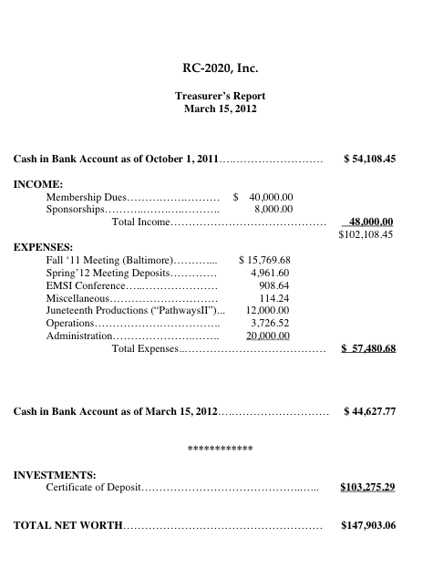

# Do you have a contact at any of these businesses or have other sponsor suggestions? If so, will you please forward information to: [janetbeauchamp@aol.com](mailto:janetbeauchamp@aol.com) Thank You!

# RC-2020

# Past and Potential Sponsors

Abbott Labs

Addison Wesley Higher Education

American Campus Communities

Apple

Aramark Higher Education

Arthur J. Gallagher

Autoarch Architects, LLC

Baker, Parker & Associates

Bank of America

Barnes & Noble College Booksellers

Collegiate Brain Trust

Chevron Energy Solutions

CBIZ

CC Benefits

Campus Works

Carnegie Melon Bank

Chartwells

Chase Manhattan Bank

CISCO

The Clements Group, L.C.

Coca Cola

Cognos

College Board

Collegis

Dain Rouscher

Datatel

Desire to Learn

EduMetry, Inc.

Energy Education

Enterasys

EthicsPoint

Ewing Marion Kaufman Foundation

Follett

Gates Foundation

Helios Foundation

Hewlett Packard

Jacob Carter Burgess

IBM

J. E. Dunn Construction

Johnson Controls

McDonalds

McGraw Hill

New York Times Education

Oracle

Pearson Education

Pearson Learning Solutions

PNC Bank

Pollen/Hauser Real Estate

Primera Engineers, Ltd.

Protocol, Inc.

RBC – Dain Rauscher

RHJ, International

Richter7

SCT

Starbucks

Synch-Solutions

Sodexo

Solutions 21

3D/I

TIAA-CREF

Wells Fargo

Xerox